Transportation
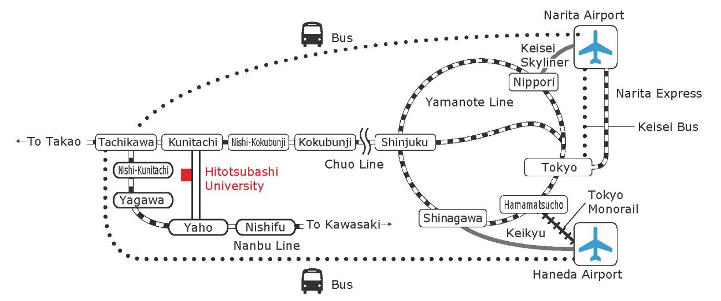

From TOKYO (東京) or SHINJUKU (新宿) station
Take JR Chuo Line (中央線) bound for Takao（高尾）direction, to KUNITACHI (国立) station. Please note: if you get on a special rapid service train, “TOKUBETSU KAISOKU (特別快速)”, make sure to change at KOKUBUNJI (国分寺) station to a rapid service train “KAISOKU” (快速) , as the Tokubetsu Kaisoku DOES NOT STOP at Kunitachi station.
Commuting time: Approximately 1 hour from Tokyo, 40 minutes from Shinjuku.

《 JR Chuo Line 》
Tokyo
↓
\550 (1hour)
↓
↓ Shinjuku
↓ ↓
↓ ↓ \390 (40 minutes)
↓ ↓
Kunitachi
↑ ¥140 (3 minutes)
Tachikawa

From HANEDA AIRPORT (羽田空港)
<Limousine Bus>
Take Limousine Bus service to TACHIKAWA RAILWAY STATION NORTH EXIT (立川駅北口) or to PALACE HOTEL TACHIKAWA (パレスホテル立川), departing every one hour. [Bus stop #4 at the International Terminal]
From Tachikawa station, take JR Chuo Line bound for Tokyo to Kunitachi station (one stop). Or you may take a taxi to the campus (approx.1,400 yen).
Commuting time in total: Approximately 2 hours.
http://hnd-bus.com/route/haijima.html

Haneda Airport
↓ \1,550 (2 hours) Limousine Bus
Tachikawa

<TOKYO MONORAIL (東京モノレール) >
Take Tokyo Monorail to HAMAMATSUCHO (浜松町) station, change to JR Yamanote (山手線) Line in direction to Tokyo. From Tokyo station, take JR Chuo Line to Kunitachi station. Commuting time: Approximately 1.5 hours.
http://www.tokyo-monorail.co.jp/english/guidance/index.html

Haneda Airport
↓ \490 (14 minutes) TOKYO MONORAIL
Hamamatsucho
↓ \160 (6 minutes) JR Yamanote-Line
Tokyo
↓ \550 (1 hour) JR Chuo-Line
Kunitachi

<KEIKYU AIRPORT LINE （京急空港線）>
Take Keikyu Airport Line (京急空港線）to SHINAGAWA (品川）station, change to JR Yamanote Line bound for Shibuya（渋谷）/Shinjuku（新宿）direction. Get off at Shinjuku station, change to JR Chuo Line to Kunitachi station.
Commuting time: Approximately 1 hour.
http://www.haneda-tokyo-access.com/en/

Haneda
↓ \410 (11 minutes) KEIKYU AIRPORT LINE
Shinagawa
↓ \200 (19 minutes) JR Yamanote-Line /clockwise
Shinjuku
↓ \390 (40 minutes) JR Chuo-Line
Kunitachi

From NARITA AIRPORT (成田空港)
<Limousine Bus>
Take Limousine Bus service to PALACE HOTEL TACHIKAWA (パレスホテル立川), departing 3 services in the morning, 6 services in the afternoon. [Bus stop #11 or 2 at the Terminal 1; # 6 or 16 at the Terminal 2; # 4 at the Terminal 3] From Tachikawa station, take JR Chuo Line bound for Tokyo to Kunitachi station, or use taxi service to the campus.
Commuting time: Approximately 3 hours
http://www.limousinebus.co.jp/en/platform_searches/index/2/102

Narita Airport
↓ \3,600 (3 hours) Limousine Bus
Tachikawa
↓ \140 (3 minutes) JR Chuo Line
Kunitachi

<KEISEI BUS (京成バス)>
Take Keisei Bus service to TOKYO STATION YAESU GATE (東京駅八重洲口), departing 3 services per hour. From Tokyo station, take JR Chuo Line to Kunitachi station.
Commuting time: Approximately 2.5 hours (1.5 hours for the bus, 1 hour for the train.)
http://www.keiseibus.co.jp/en/kousoku/nrt16.html

Narita Airport
↓ \3,190 (1hour 15minutes) KEISEI BUS
Tokyo
↓ \550 (1hour) JR Chuo-Line
Kunitachi

<NARITA EXPRESS (成田エクスプレス) train>
Take Narita Express train to Tokyo station or to Shinjuku station, change to JR Chuo Line to Kunitachi station.
Commuting time: Approximately 2 hours.
http://www.jreast.co.jp/e/nex/

Narita Airport
↓ \3,020 (1hour) NARITA EXPRESS train
Tokyo
↓ \550 (1hour) JR Chuo-Line
Kunitachi
--------------------------------------------------------------------------------------
Narita Airport
↓ \3,190 (1hour 20minutes) NARITA EXPRESS train
Shinjuku
↓ \390 (40minutes) JR Chuo-Line
Kunitachi

Hitotsubashi University
About 10 minutes’ on foot from the SOUTH exit of JR Kunitachi station. Walk straight down the main avenue, on your right sidewalk. The conference will be held on the west side of our campus (on your right from the Kunitachi station.)

Hitotsubashi University: http://www.hit-u.ac.jp/eng/
Directions to the campus from Kunitachi Station: http://www.hit-u.ac.jp/eng/about/direction/kunitachi.html
Campus map: http://www.hit-u.ac.jp/eng/about/direction/guide/campus/e-campus/index.html

