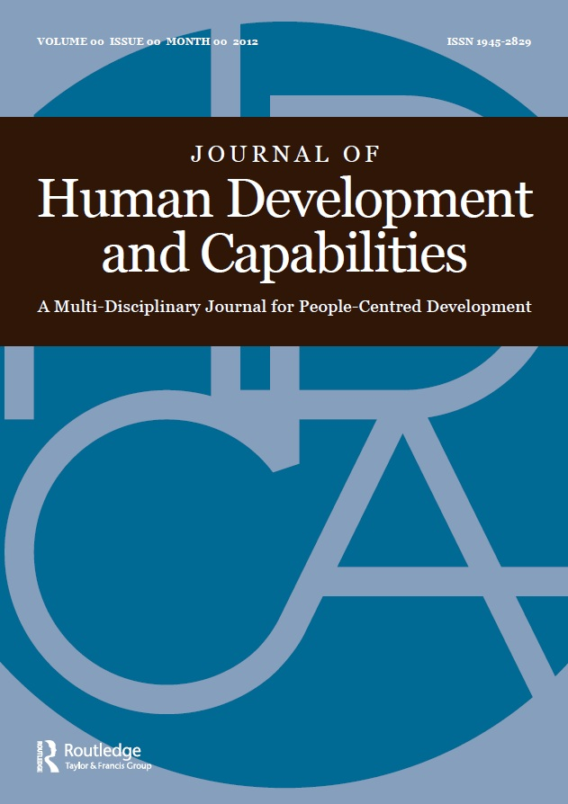
Journal of Human Development and Capabilities

Call for Papers

Thematic Issue on Sustainable Development Goals – politics of indicators in local strategies (“Power of Numbers Phase 2”)

Guest editors: Sakiko Fukuda-Parr and Angelina Fisher

Theme
The adoption of the Sustainable Development Goals (SDGs) reflects the rise of global goal-setting as a tool for setting and shaping an international development agenda. SDGs follow the Millennium Development Goals (MDGs), which had mobilized attention to development and poverty reduction as a global priority. Yet as social scientists have long pointed out, the use of quantitative targets and indicators can alter power relations, affect distribution of resources, reorganize national and local priorities, create perverse incentives for performance, and produce narratives that shape thinking and communication. Many of these governance effects were evident in the experience of the MDGs.

As the articles in the 2014 JHDC special issue on the MDGs (Power of Numbers phase I) showed, these goals and targets had complex, often distorting, consequences on policy priorities and on framing development discourses. They were also often in tension with a human rights-based approach, which sees the (intangible and difficult to quantify) principles of equity, non-discrimination and participation as the cornerstone of human development. Thus, for example, complex objectives such as gender empowerment were reduced to a simple indicator (gender parity in school enrollment), which then drove narratives of development, often to the detriment of women trying to assert and secure rights of participation.

The distorting effects of goal setting are not necessarily accidental; they are shaped by the way in which targets and indicators are defined, the manner in which data is collected and the process by which the indicators are produced. These, in turn, depend on the process of contestation – both overt and obscured – amongst the various stakeholders who pursue their ideas about important objectives and strategies as well as their material interests. These processes have been studied and theorized with respect to the use of indicators as tools of global governance in diverse areas (see for example, Sally Engle Merry, The Seduction of Quantification, University of Chicago Press, 2016)

This special issue continues the exploration of the mechanisms and processes by which global goals shape narratives, influence policy priorities and redefine concepts. Through a collection of case studies, it aims to present a comparative analysis of the national and local processes of collection, analysis, and use of SDG data, as well as processes surrounding the reporting on national and sub-national progress towards SDGs. The study is particularly interested in addressing, from a comparative perspective, the following questions:

- how are global SDGs translated in local and national contexts?
- what are the implications of the SDGs and quantification on national and sub-national priorities?
- How do SDGs (or the underlying data) (re)shape the meaning of development and strategies for poverty reduction and national and sub-national levels?
- How do SDG-related processes impact the dynamic and power relations between different stakeholders? What are the processes for contestation?
- What strategies can be used to mitigate the negative governance effects of goals-and-targets-driven policies?

Papers
We invite submissions of studies analyzing national or sub-national SDG processes, either as a whole or focused on a particular targets or indicators. A case study could explore the processes by which a particular target or indicator is selected as a priority and the process of contestation that this might involve amongst the stakeholders involved. Alternatively, a study may focus on one or more indicator producers and analyze whether, and if so, how the SDG processes affect (or construct) the identity of the producer and its interaction with other stakeholders. Although the case study should focus on a specific country, sub-national state or province, municipality or a local community, a study of networks, formal and informal, that form around the indicator is also welcome.

Process and timeline
Interested authors are invited to submit a proposal of a case study

The proposal should include an abstract outlining the study’s objectives and methodology.

The deadline for submission of proposals: 15 May, 2017.
Selection of papers and notification to authors: 15 June 2017
Short meeting of authors at the HDCA conference: September 2017
Submission of complete papers for peer review: March 2018
Presentation of papers at HDCA conference panel: Summer 2018
Publication: JHDC 2019

Submissions should be sent to the guest editor: Sakiko Fukuda-Parr by email – fukudaps@newschool.edu

